**File Permission Task**

**Task Description:**

Create a file with .txt extension (/home/demo.txt). Change the permission set of that file, so that any user can read it, group can read/write & owner can read/write/execute it.

**Solution :**

**Create a file /home/demo.txt with these permissions:**

* **Owner**: Can read, write, execute → rwx (7)
* **Group**: Can read, write → rw- (6)
* **Others**: Can read → r— (4)

**✅ 1. Create the file:**

* touch /home/demo.txt 🡪 Creating a file in /home.

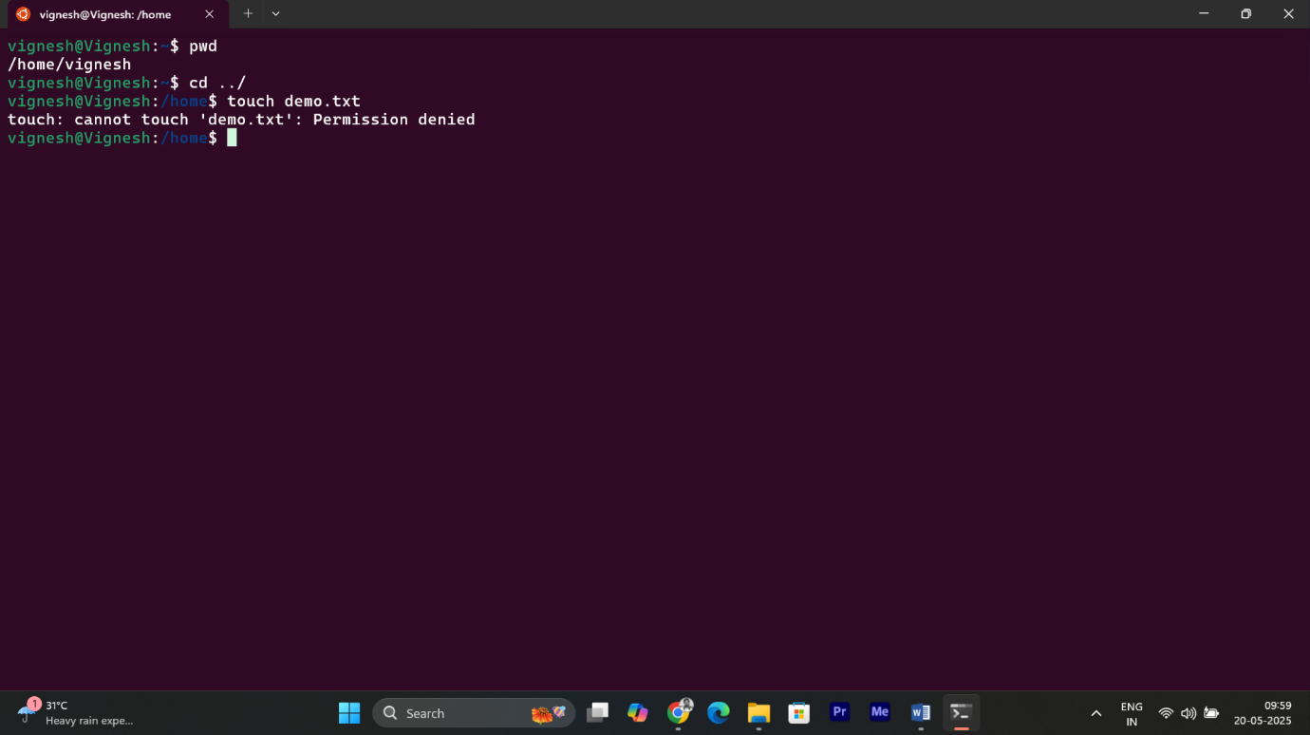

“I don't have permission to create or modify files directly in /home, so I need to switch to the root user to change the permissions.”

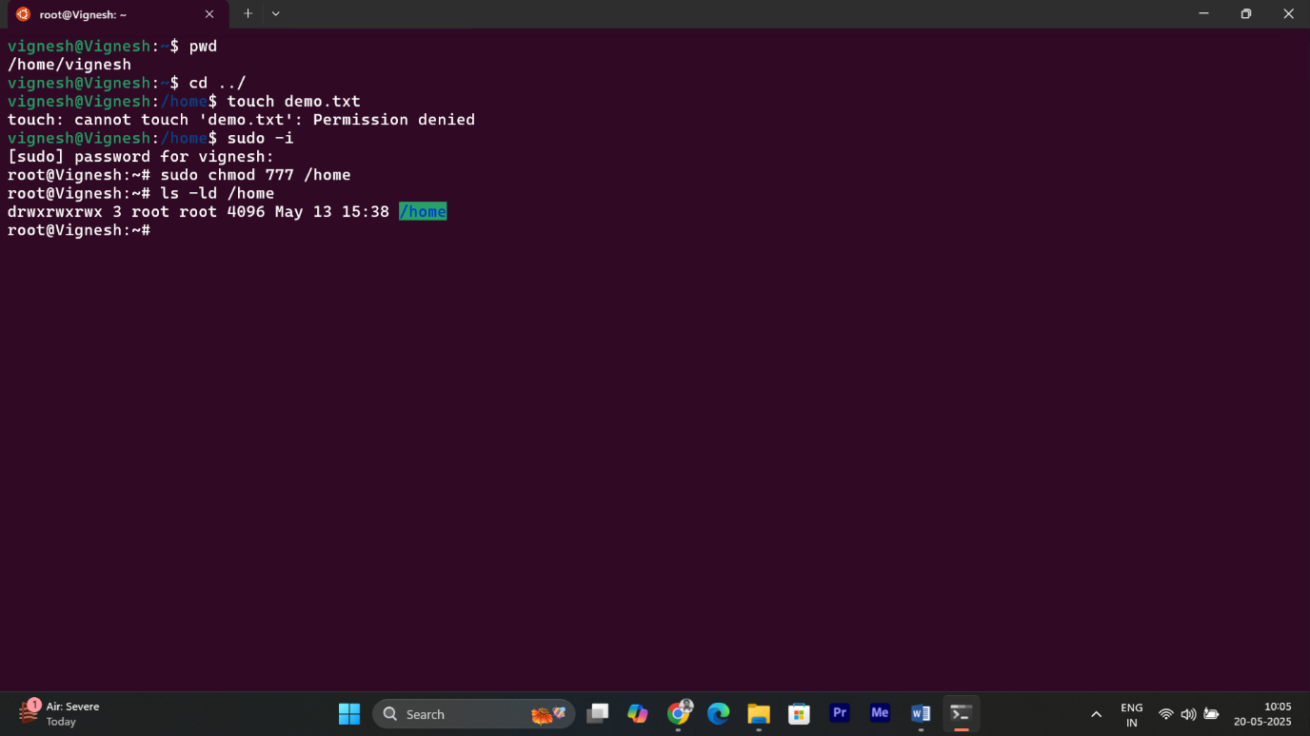

* Sudo -i 🡪 Login as **root User** (administrator mode).
* Sudo chmod 777 /home 🡪 Gives you all permission to /home.

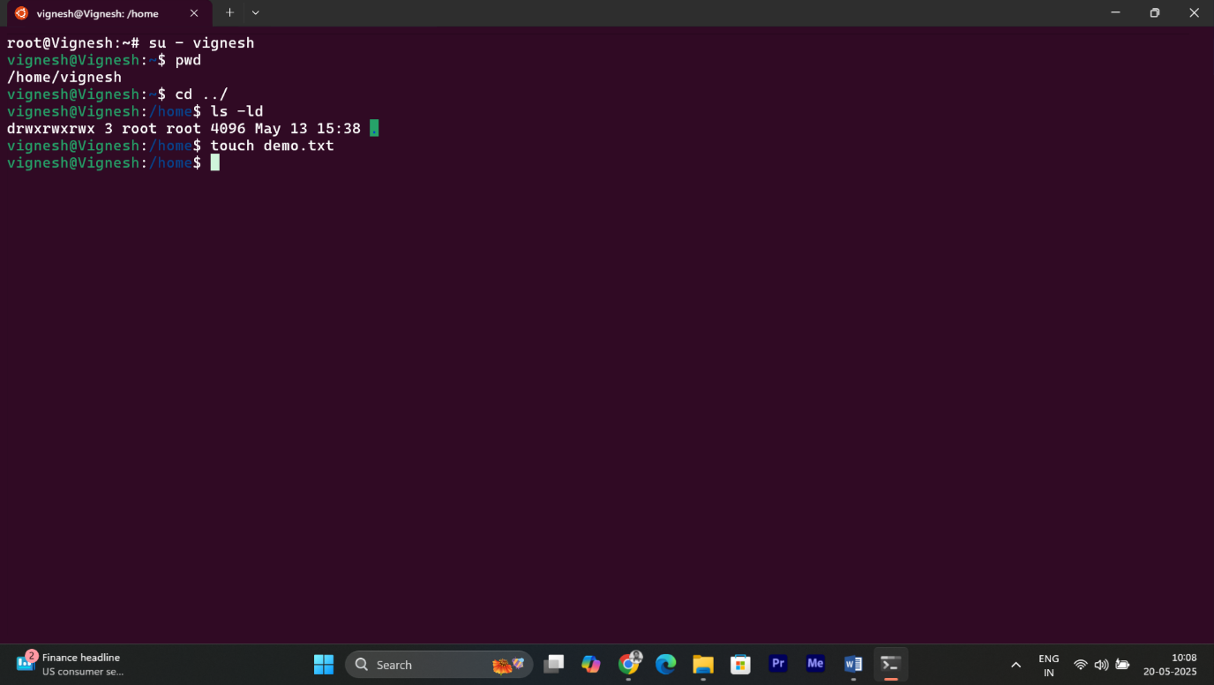

Then I logged back in as the user vignesh and checked the permissions of /home, and created the file.

* su – vignesh 🡪 **Switch to Another User(vignesh)**

**✅ 2. Change the permission:**

Any user can read it, group can read/write & owner can read/write/execute it.

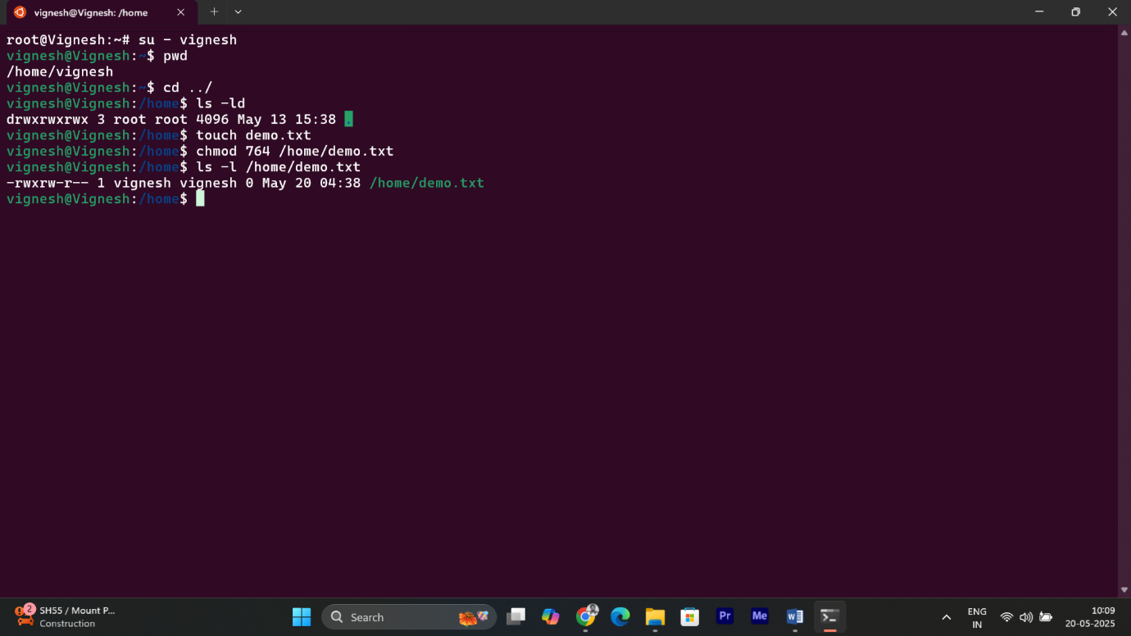

* Chmod 🡪 Change the permission.

7 = rwx (owner)

6 = rw- (group)

4 = r-- (others)

* ls -ld 🡪 prints the files with permission.